User Guide of Online Roll Call App
- After enter the home page, please click the login button to log in with google account.
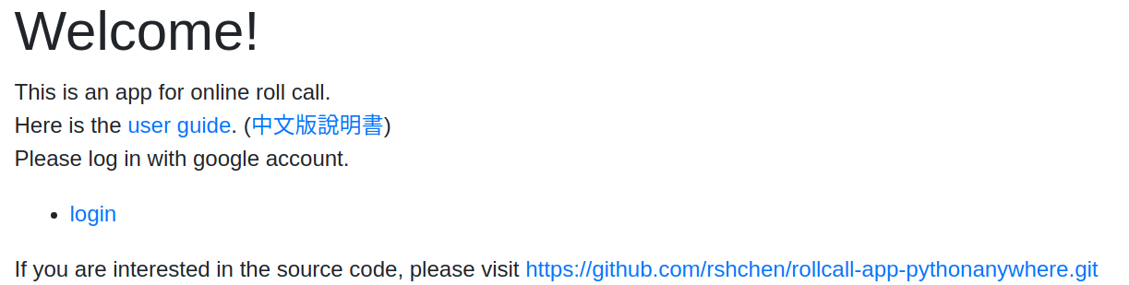
- Please choose the role to enter the app.
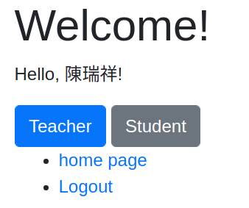
- If you are teacher, please key in the name list of students separated by line breaks.
(tip: You can copy and paste the name list from excel directly.)
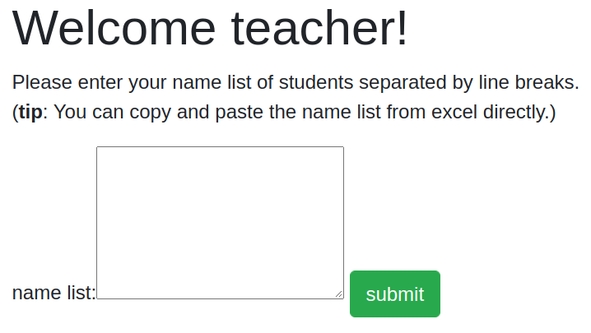 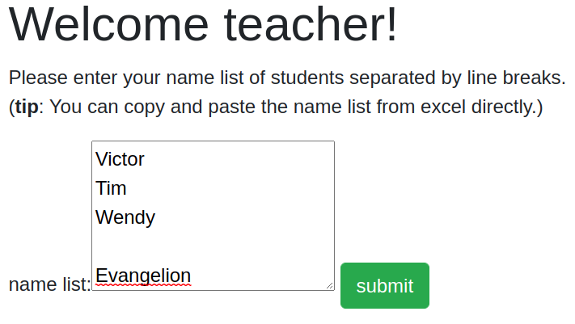
- After click the submit button, you will see the name list below.
Please click the check button after you check the name list.
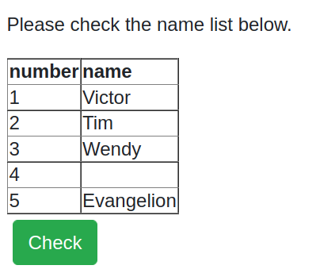
- Now you are in the attendance list page. Please send the classroom ID to your students.
After that, students can sign in with the ID.
When you click on the roll call button, you can see whether the student singed in from the attendance column with “O,X”.
The account column shows the students’ google accounts using to sign in.
(Note: If you exit this page, the informations submitted by students will be removed.)
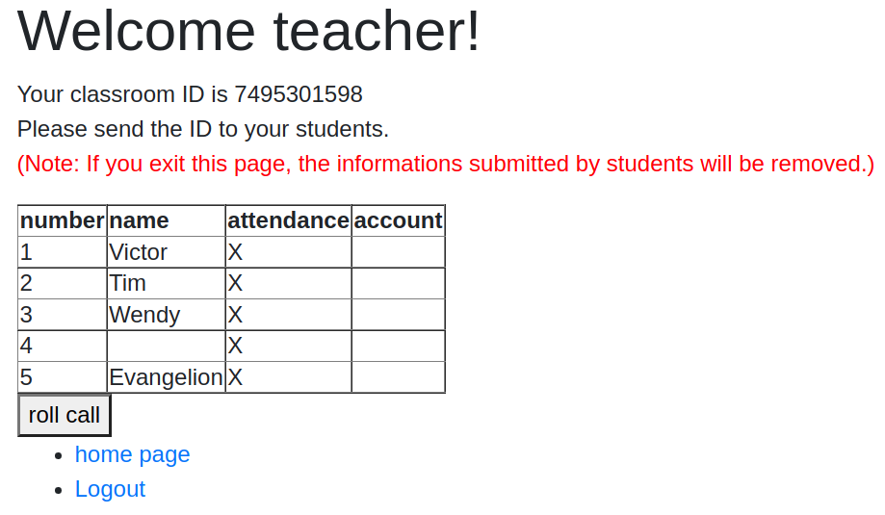 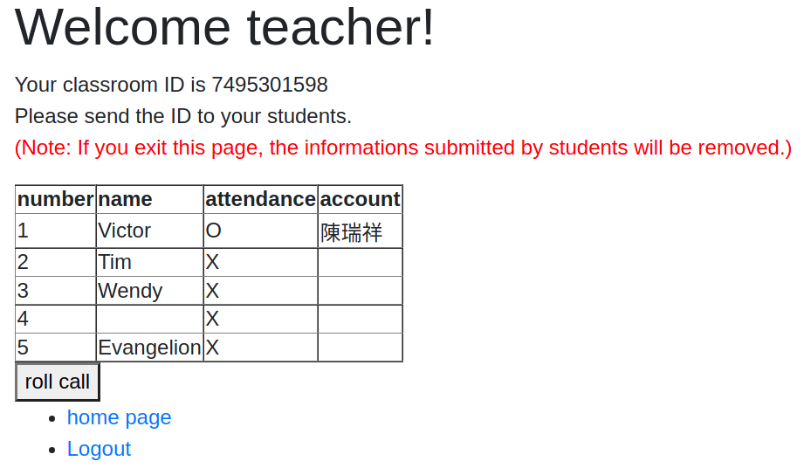
- 學生登入app後，並選擇學生身份進入後，請submit送交老師傳來的classroom ID以進入點名畫面。
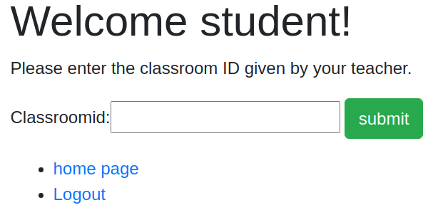
- 請點選自己的名字並submit送交。
